SANDY’S LAW

Bill 43, is an amendment to the Liquor Licence Act

Mandatory Signage Requirement
The Liquor Licence Act requires all establishments that sell or dispense alcohol to post signs warning women that drinking alcohol during pregnancy can cause Fetal Alcohol Spectrum Disorder.
The warning sign must be at least 8 by 10 inches in size, to be printed in landscape format (horizontally). It must be prominently displayed in all locations where beverage alcohol is sold or dispensed including where customers brew their own wine or beer for take home consumption. Failure to comply with the signage requirements is an offence under the Liquor Licence Act.
The following types of premises must post the warning sign:
- Restaurants and bars licensed to sell alcohol (wine, beer and spirits);
- LCBO stores and other retail stores authorized to sell alcohol (i.e., The Beer Store; wine, beer and spirits manufacturers´ stores, including occasional extensions of on-site winery retail stores within farmers’ markets; grocery stores authorized to sell liquor to the public); and
- Licensed ferment on premise facilities.
If you have questions about your obligation under the Liquor Licence Act, please contact the Alcohol and Gaming Commission of Ontario at 416-326-8700 or toll free at 1-800-522-2876.

For more info and signage download please refer to the AGCO website: https://www.agco.ca/general/general-information-signage-requirement-sandys-law
Download the Sandy’s Law Warning Sign at https://www.agco.ca/general/general-information-signage-requirement-sandys-law

Liquor Licence Act,

R.S.O. 1990, c. L.19

Requirement to display sign
30.1 (1) No person shall sell or supply liquor or offer to sell or supply liquor from a prescribed premises unless,
(a) the premises prominently displays a warning sign containing the prescribed information that cautions women who are pregnant that the consumption of alcohol during pregnancy is the cause of Fetal Alcohol Spectrum Disorder;
(b) the sign is posted at the premises in accordance with the prescribed criteria; and
(c) the sign satisfies any other criteria that are prescribed. 2004, c. 12, s. 1.

R.R.O. 1990, Regulation 718

Under the Liquor Licence Act

Warning Regarding

Consumption of Alcohol

During Pregnancy

26.1 (1) The warning sign referred to in subsection 30.1 (1) of the Act shall be in the form posted on the website of the Alcohol and Gaming Commission of Ontario and bearing the words “WARNING: Drinking alcohol during pregnancy can cause birth defects and brain damage to your baby”. O. Reg. 434/04, s. 1; O. Reg. 296/15, s. 11 (1).
Failure to comply with the signage requirements is an offence under the Liquor Licence Act, with a maximum penalty of a $250,000 fine for a corporation, or a $100,000 fine and/or imprisonment for up to one year for an individual.

(3) The warning sign shall be at least 8 inches by 10 inches in size. O. Reg. 434/04, s. 1.
(4) The following premises are required to display the warning sign:
1. Premises to which a licence to sell liquor applies.
2. Premises to which a licence to operate a brew on premise facility applies.
3. A government store. O. Reg. 434/04, s. 1.
(5) The warning sign shall be prominently displayed and visible to patrons, as follows:
1. On premises with a licence to sell liquor, in a location where liquor is sold and served.
2. On premises with a licence to operate a brew on premise facility, in a location where persons make beer or wine.
3. In a government store, in a location where liquor is purchased. O. Reg. 434/04, s. 1.
Sandy’s Law Sign
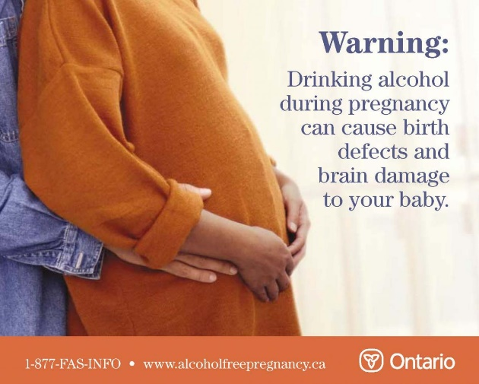
DID YOU KNOW…
No amount or type of alcohol is safe to consume during pregnancy
We invite all retailers and eating/drinking establishments
to make sure that they are in compliance with SANDY’S LAW
and inform the public of the risks associated with consuming alcohol at any time during pregnancy.

www.hamiltonfasdsupport.ca
Hamilton FASD Parent & Caregiver Support Group, an Affiliate member of FASworld Canada

